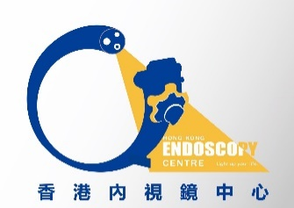
Room 1725A, 17 th floor, phase I, The Grand Plaza Mong Kok, Kowloon Tel: 23532180 Fax 2352 2666
Hong Kong Endoscopy Centre

Non-Endoscopist Registration Form B

Doctor Name: _____________________________ (Chinese_______________________)
Use company name on bill? __ Y ____N Company Name__________________________
Business Registration Number: (if any)___________________________________________
Clinic Address______________________________________________________________
Tel No: _________________________ Fax No: _________________________________
E-mail: _________________________Emergency contact mobile No.:__________________
Contact person for billing matters: _________________________ Tel No.:_______________
Billing or A/C Dept. address (if different to clinic address):
___________________________________________________________________________

Your payment information for our Centre to pay to.

Doctor’s Signature___________________________ Date: _________________________

Please complete and return this form, with your name card and a copy of your certificates of Business registration, Medical Protection Society and Annual Practicing Certificate to the Centre by mail or fax.

